NAME: SWATHI V
ROLL NO:24BAD122
EX NO:2 MACHINE LEARNING
To implement and optimize linear regression and logistic regression models using real-world datasets and analyze their performance.
SCENARIO 1:
Predict ocean water temperature using environmental and depth-related features.
OUTPUT:
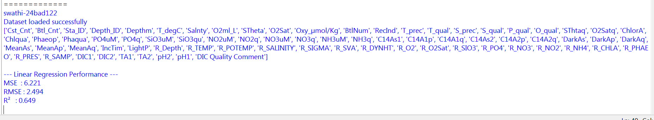
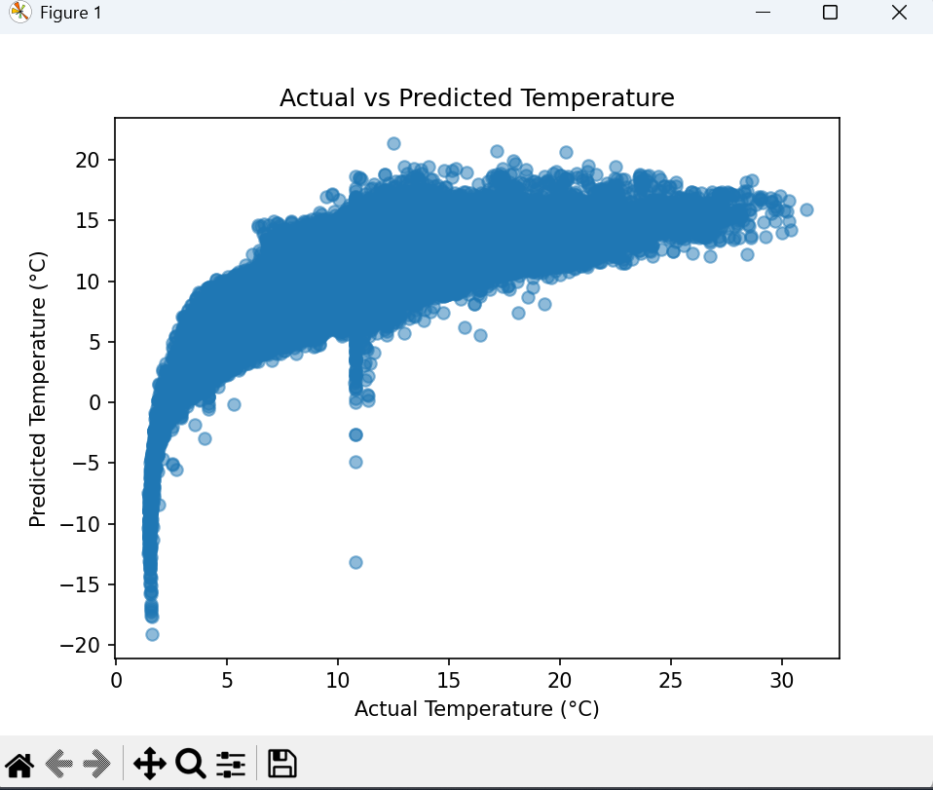
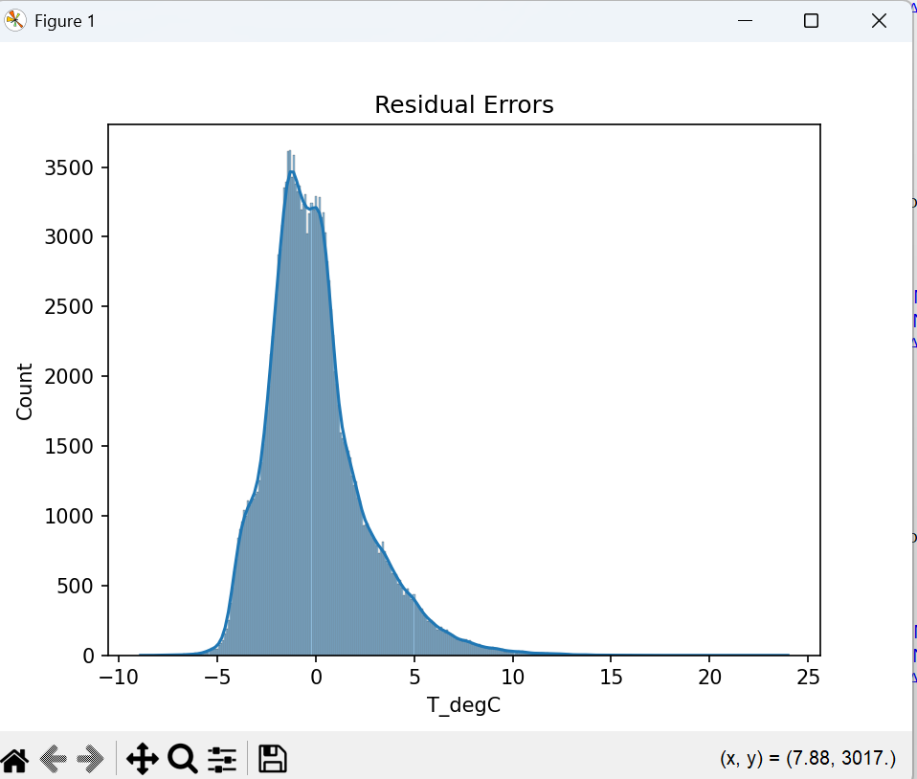
SCENARIO 2:
Classify whether LIC stock price will increase (1) or decrease (0) based on historical data.
OUTPUT:
